Experiment Number : 10 Date:
Implementation of Access Modifiers in Java

Aim:
Write a Java program to implement different access modifiers.

PRE LAB EXERCISE
QUESTIONS
- What are the 4 access modifiers available in Java?
Java provides four access modifiers: public, private, protected, and default (no modifier). They control the visibility of classes, methods, and variables across classes, packages, and subclasses in a program.

- Which access modifiers can be used in Java to control access to class members?
To control access to class members (variables, methods, constructors), Java uses public, private, protected, and default access modifiers. These determine whether members are accessible within the class, package, subclasses, or everywhere.

IN LAB EXERCISE
Objective
To demonstrate different access modifiers such as Default, Private, Protected and Public using Java programs.
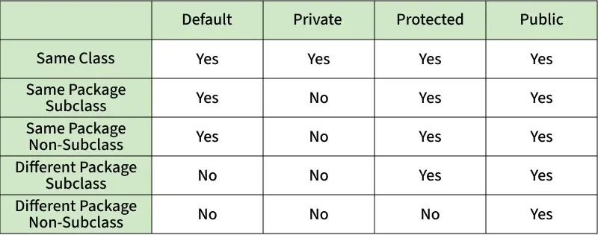
Fig: Comparison table of Access Modifiers in Java
Source Code
// Default Access modifier
class Car {
String model; // default access
}
public class Main {
public static void main(String[] args){
Car c = new Car();
c.model = "Tesla"; // accessible within the same package
System.out.println(c.model);
}
}
Output:
Tesla

//Private Access Modifier
class Person {
// private variable
private String name;
public void setName(String name) {
this.name = name; // accessible within class
}
public String getName() {
return name;
}
}
public class Geeks {
public static void main(String[] args)
{
Person p = new Person();
p.setName("Alice");

// System.out.println(p.name);
// Error: 'name'
// has private access
System.out.println(p.getName());
}
}
Output
Alice

//Protected Access Modifier
class Vehicle {
protected int speed; // protected member
}
class Bike extends Vehicle {
void setSpeed(int s)
{
speed = s; // accessible in subclass
}
int getSpeed()
{
return speed; // accessible in subclass
}
}
public class Main {
public static void main(String[] args){
Bike b = new Bike();
b.setSpeed(100);
System.out.println("Access via subclass method: "+ b.getSpeed());
Vehicle v = new Vehicle();
System.out.println(v.speed);
}
}
Output
Access via subclass method: 100
0

//Public Access Modifier
class MathUtils {
public static int add(int a, int b) {
return a + b;
}
}
public class Main {
public static void main(String[] args) {
System.out.println(MathUtils.add(5, 10)); // accessible anywhere
}
}
Output
15

POST LAB EXERCISE
  - Write a Java program to implement Default access modifier which has a default class within the same package and a default class from a different package.
Default access allows access only within the same package. It cannot be accessed from a different package.

File: Package1/DefaultClass.java
package Package1;

class DefaultClass { // default access
void display() {
System.out.println("Default access method");
}
}

File: Package1/TestDefault.java
package Package1;

public class TestDefault {
public static void main(String[] args) {
DefaultClass obj = new DefaultClass();
obj.display(); // Accessible within same package
}
}

File: Package2/TestAccess.java
package Package2;
import Package1.DefaultClass; // Error: not accessible

public class TestAccess {
public static void main(String[] args) {
DefaultClass obj = new DefaultClass(); // Compilation error
}
}

  - Which access modifier provides the highest level of access?
The public access modifier provides the highest level of access. Public classes, methods, and variables can be accessed from any other class in any package throughout the entire Java application.

ASSESSMENT

Description | Max Marks | Marks Awarded
Pre Lab Exercise | 5
In Lab Exercise | 10
Post Lab Exercise | 5
Viva | 10
Total | 30
Faculty Signature

